**Component Name**: Angular-i18

**Component Functionality**:

This is a multilingual application. US English is the default language set for the app. User can select language of his choice from the drop down shown on the top left corner of the screen, accordingly the translation of the contents will take place on the fly.

**Usage Areas**:

Can be used for building multilingual sites. Language is an integral part of various cultures around the world. It is pleasing for some locals to view the web content in their local language. Localization has the below benefits:

a) Improves the user experience by rendering the site in a preferred manner.

b) Drives more traffic due to better user interest in the personalized content.

c) Improves product sales across the world due to support from the local crowd in multiple regions.

d) Can act as a USP for the web application in the market.

The internationalization of an application reduces the overall time and effort spent on building and maintaining a multilingual site. It structures the site such that a single website could serve content in multiple languages with minimal effort.

**Component Technical details**:

* Angular cli version: 9.1.8
* Typescript version: 3.8.3
* ngx-translate/core version: 12.1.2
* bootstrap version: 4.5.0

**How this component can be integrated with other Applications**:

Depending on the need json files can be added for the languages to be supported by the application. They are to be added in the folder i18n under assets folder.

**Screenshots**:

1. **Initial screen**:

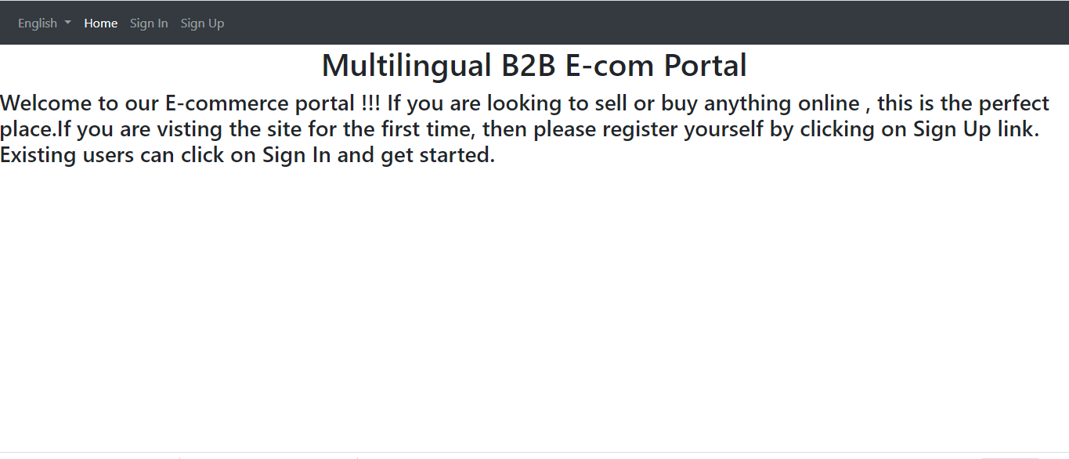

1. **User can change the language setting from the drop down on the top-left corner. If user selects French:**

